Design Principles - Liskov Substitution Principle (LSP)
# Source: AI Source: Provided by: [Data Path: Persons Table -> ID Column: 1, Name_En Column: Motasem Essam] -> From: [ChatGPT] on [1/23/2026]
The Liskov Substitution Principle states that subtypes must be substitutable for their base types without altering the correctness of the program.
👉 Think of it like replacing a light bulb with another of the same type — it should work seamlessly without breaking the lamp.

🔑 Key Points
# Source: AI Source: Provided by: [Data Path: Persons Table -> ID Column: 1, Name_En Column: Motasem Essam] -> From: [ChatGPT] on [1/23/2026]
• Subclasses should behave consistently with their parent classes
• Derived classes must not violate expectations of the base class
• Supports reliable polymorphism and modular design
• Reduces runtime errors and surprises

❌ Bad Example
# Source: AI Source: Provided by: [Data Path: Persons Table -> ID Column: 1, Name_En Column: Motasem Essam] -> From: [ChatGPT] on [1/23/2026]
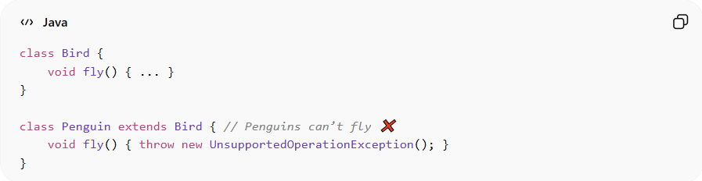
class Bird {
void fly() { ... }
}

class Penguin extends Bird { // Penguins can’t fly ❌
void fly() { throw new UnsupportedOperationException(); }
}
Problems:
• Substitute Penguin for Bird → program breaks
• Violates LSP
• High risk of runtime errors
• Reduces reliability and maintainability

✅ Good Example
# Source: AI Source: Provided by: [Data Path: Persons Table -> ID Column: 1, Name_En Column: Motasem Essam] -> From: [ChatGPT] on [1/23/2026]
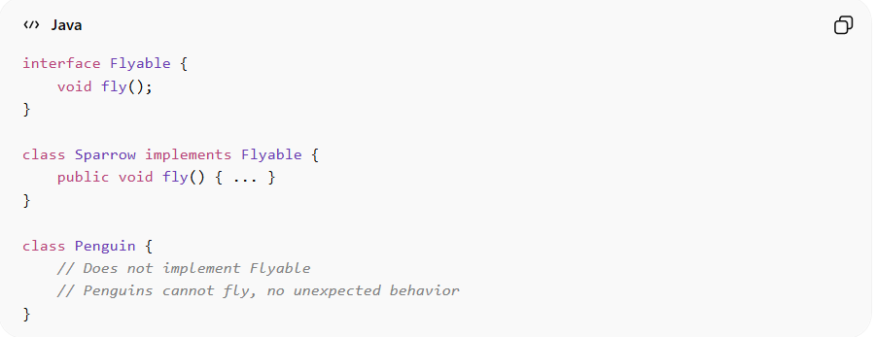
interface Flyable {
void fly();
}

class Sparrow implements Flyable {
public void fly() { ... }
}

class Penguin {
// Does not implement Flyable
// Penguins cannot fly, no unexpected behavior
}
Benefits:
• Ensures substitutable behavior
• Supports safe polymorphism
• Makes systems more predictable, reliable, and maintainable
• Reduces bugs and unexpected runtime errors

⚡ When to Apply
# Source: AI Source: Provided by: [Data Path: Persons Table -> ID Column: 1, Name_En Column: Motasem Essam] -> From: [ChatGPT] on [1/23/2026]
• Always — especially in polymorphic systems
• Important for inheritance and interface-based design
• Works best with SRP and OCP
• Useful when designing libraries, APIs, or reusable components

